**A**

***PROJECT REPORT***

*on*

***HR Resume Processing System using MAKE***

*Submitted in partial fulfilment of the requirements for the degree of*

**BACHELOR OF TECHNOLOGY**



Session: - 2024

Submitted by

Chirag Joshi (20ETCCS023)

Pratham Singh Tanwar (20ETCCS090)

Gaurav Vashishtha (20ETCCS042)

Mohammed Anjar (20ETCCS073)

Under Guidance of

Mr. Aaditya Maheshwari

Assistant Professor

Dept. of CSE TINJRIT, Udaipur

**DEPARTMENT OF COMPUTER SCIENCE AND ENGINEERING**

**TECHNO INDIA NJR INSTITUTE OF TECHNOLOGY, UDAIPUR-313001**

**2024**

**A**

***PROJECT REPORT***

*On*

**HR Resume Processing System using MAKE**

*Submitted in partial fulfilment of the requirements for the degree of*

**BACHELOR OF TECHNOLOGY**



**Session: - 2024**

Submitted by

Chirag Joshi (20ETCCS023)

Pratham Singh Tanwar(20ETCCS090)

Gaurav Vashishtha (20ETCCS042)

Mohammed Anjar (20ETCCS073)

8th Sem (CSE)

Under Guidance of

Mr. Aaditya Maheshwari

Assistant Professor

Dept. of CSE TINJRIT, Udaipur

**DEPARTMENT OF COMPUTER SCIENCE AND ENGINEERING**

**TECHNO INDIA NJR INSTITUTE OF TECHNOLOGY, UDAIPUR-313001**

**2024**



Department of Computer Science and Engineering

Techno India NJR Institute of Technology, Udaipur-313001

**Certificate**

This is to certify that project work titled **HR Resume Processing System using MAKE** by **Chirag Joshi** was successfully carried out in the Department of Computer Science and Engineering, TINJRIT and the report is approved for submission in the partial fulfillment of the requirements for award of degree of Bachelor of Technology in Computer Science and Engineering.

Mr. Aaditya Maheshwari Dr. Rimpy Bishnoi

Assistant Professor Head of Department

Dept. of CSE TINJRIT, Udaipur Dept. of CSE TINJRIT, Udaipur

Date Date



Department of Computer Science and Engineering

Techno India NJR Institute of Technology, Udaipur-313001

**Certificate**

This is to certify that project work titled **HR Resume Processing System using MAKE** by **Pratham Singh Tanwar** was successfully carried out in the Department of Computer Science and Engineering, TINJRIT and the report is approved for submission in the partial fulfillment of the requirements for award of degree of Bachelor of Technology in Computer Science and Engineering.

Mr. Aaditya Maheshwari Dr. Rimpy Bishnoi

Assistant Professor Head of Department

Dept. of CSE TINJRIT, Udaipur Dept. of CSE TINJRIT, Udaipur

Date Date



Department of Computer Science and Engineering

Techno India NJR Institute of Technology, Udaipur-313001

**Certificate**

This is to certify that project work titled **HR Resume Processing System using MAKE** by **Gaurav Vashishtha** was successfully carried out in the Department of Computer Science and Engineering, TINJRIT and the report is approved for submission in the partial fulfillment of the requirements for award of degree of Bachelor of Technology in Computer Science and Engineering.

Mr. Aaditya Maheshwari Dr. Rimpy Bishnoi

Assistant Professor Head of Department

Dept. of CSE TINJRIT, Udaipur Dept. of CSE TINJRIT, Udaipur

Date Date



Department of Computer Science and Engineering

Techno India NJR Institute of Technology, Udaipur-313001

**Certificate**

This is to certify that project work titled **HR Resume Processing System using MAKE** by **Mohammed Anjar** was successfully carried out in the Department of Computer Science and Engineering, TINJRIT and the report is approved for submission in the partial fulfillment of the requirements for award of degree of Bachelor of Technology in Computer Science and Engineering.

Mr. Aaditya Maheshwari Dr. Rimpy Bishnoi

Assistant Professor Head of Department

Dept. of CSE TINJRIT, Udaipur Dept. of CSE TINJRIT, Udaipur

Date Date

**Examiner Certificate**

This is to certify that the following student

**Chirag Joshi, Pratham Singh Tanwar, Gaurav Vashishtha and Mohammed Anjar** of final year B.Tech. (Computer Science and Engineering), was examined for the project work titled

***HR Resume Processing System (MAKE)***

during the academic year 2023 – 2024 at Techno India NJR Institute of Technology, Udaipur

**Remarks:**

**Date:**

Signature Signature

(**Internal Examiner**) (**External Examiner**)

Name :- Name :-

Designation:- Designation:-

Department: - Department: -

Organization:- Organization:-

**ACKNOWLEDGMENT**

We take this opportunity to record our sincere thanks to all who helped us to successfully complete this work. Firstly, We are grateful to our **supervisor Mr. Aaditya Maheshwari.**

for his invaluable guidance and constant encouragement, support and most importantly for giving us the opportunity to carry out this work.

We would like to express our deepest sense of gratitude and humble regards to our

**Head of Department Dr. Rimpy Bishnoi** for giving invariable encouragement in our endeavors and providing necessary facility for the same. Also a sincere thanks to all faculty members of CSE, TINJRIT for their help in the project directly or indirectly.

Finally, We would like to thank my friends for their support and discussions that have proved very valuable for us. We are indebted to our parents for providing constant support, love and encouragement. We thank them for the sacrifices they made so that we could grow up in a learning environment. They have always stood by us in everything we have done, providing constant support, encouragement and love

**Chirag Joshi (20ETCSS023)**

**Pratham Singh Tanwar (20ETCCS090)**

**Gaurav Vashishtha (20ETCCS042)**

**Mohammed Anjar (20ETCCS073)**

DEPARTMENT OF COMPUTER SCIENCE AND ENGINEERING

TECHNO INDIA NJR INSTITUTE OF TECHNOLOGY, UDAIPUR-313001

**CONTENTS**

|  |  |
| --- | --- |
| **Name of Contents** | **Page no.** |
| Certificate 1 | 3-6 |
| Certificate 2 | 7 |
| Acknowledgements | 8 |
| Contents | 9 |
| List of Figures | 10 |
| Chapter 1: Introduction   * 1. Title of Project   2. Objective of the Project   3. Tool Used   4. Tool Advantages and Disadvantages | 11  11  12  14  15 |
| Chapter 2: Implementation  2.1 Step 1: Watching Email  2.2 Step 2: Managing Attachments and Organizing Files  2.3 Step 3: Search for a file or folder  2.4 Step 4: Get Content of a document  2.5 Step 5: Gathering Information from resume  2.6 Step 6: Storing Information in Google Spreadsheet  2.7 Step 7: Sending email to the candidate | 17  17  20  23  25  28  30  33 |
| Conclusion | 36 |
| Future Scope | 37 |
| Bibliography | 39 |

**LIST OF FIGURES**

|  |  |
| --- | --- |
| Fig.1 Gmail Module | 18 |
| Fig.2 Gmail Module Setting | 19 |
| Fig.3 Google Drive Module | 21 |
| Fig.4 Google Drive Module Setting | 22 |
| Fig.5 Google Drive module setting for searching the file from the folder | 24 |
| Fig.6 Google Docs module | 26 |
| Fig.7 Google Docs Setting | 27 |
| Fig.8 0Codekit module | 29 |
| Fig.9 0codekit Setting | 29 |
| Fig.10 Google Sheets module | 31 |
| Fig.11 Google Sheets Setting | 32 |
| Fig.12 Google Mail Setting for sending response mail | 34 |
| Fig.13 Final Scenario | 35 |

**CHAPTER 1: INTRODUCTION**

**Name of the project:**

HR Resume Processing System (MAKE)

**Problem Statement:**

ZZ Enterprises would like to automate their HR functions related to processing incoming resumes or enquiries.

Currently, resumes are received in the HR inbox either from individuals or from other job portals.

All incoming emails into the HR inbox should be scanned and those that pertain to an opportunity (existing or otherwise) should be moved to a Resumes folder.

If the email contains an attachment, then it must be scanned and if it is indeed a resume, then the file needs to be saved into a Resumes folder ideally named as "Resumes «today's date>" for E.g., "Resumes 20-Sep-2023" for the run-on 20th September 2023 in a shared location.

In addition to this, the following information of the sender should be entered into an excel sheet called "Candidate Information". This file should consist of the following columns:

**Sr no** - chronological number of the entry

**Full Name of Candidate** - first and last names as obtained from the candidate's email account or resume.

**Email id** - as obtained from the candidate's email account or resume.

**Contact number** - as obtained from the candidate's email or resume.

**Linked in URL** - as obtained from the candidate's resume.

**Date of entry** - date of receipt of email

Once entry into the excel file has been successfully completed, an email should be sent to the candidate notifying them of receipt of their email and that ZZ will get in touch with them soon. A standard format for the email may be used. Do ensure the email is addressed to the person by the candidate's first name. The email should appear to be sent by the HR team.

**Objective of project:**

* **Automation of Email Processing:**

Utilize MAKE's email modules to automate the scanning of incoming emails in the HR inbox.

Implement filters to categorize emails based on specific criteria, identifying those related to opportunities.

* **Categorization and Storage:**

Develop MAKE scenarios to categorize emails and move them to the designated "Resumes" folder.

Ensure the seamless integration of MAKE with the company's email system for real time processing.

* **Resume Attachment Handling:**

Create MAKE scenarios to handle email attachments, particularly resumes.

Use MAKE's file modules to save resumes into a shared location with a date-specific naming convention.

* **Candidate Information Updates:**

Leverage MAKE's data transformation capabilities to extract sender details from emails.

Utilize MAKE's Excel modules to update the "Candidate Information" Excel sheet with the extracted data.

* **Automated Acknowledgment Emails:**

Configure MAKE to send automated acknowledgment emails to candidates using a predefined template.

Personalize the emails by dynamically inserting the candidate's first name and ensuring they appear to be sent by the HR team.

**Tool Used:**

**MAKE :**

MAKE is a powerful and versatile no-code automation platform that can be used to automate a wide range of tasks across different departments and industries. It is a great choice for businesses of all sizes that are looking to save time and improve efficiency.

MAKE is a powerful no-code automation platform that allows users to connect their favorite apps and services together without any coding skills. It provides a wide range of features, including:

**• Visual workflow builder:** MAKE's visual workflow builder MAKEs it easy to create and manage automation workflows. Users can simply drag and drop pre-built modules to create complex workflows without writing any code.

**• Wide range of integrations:** MAKE integrations with over 1,000 popular apps and services, including Gmail, Slack, Salesforce, and many more. This allows users to automate a wide range of tasks, such as sending emails, creating new tasks, and updating CRM records.

**• Powerful scripting language:** MAKE also includes a powerful scripting language that allows users to create custom automations. This MAKEs it possible to automate even the most complex tasks, such as integrating with custom APIs or building machine learning models.

MAKE is used by businesses of all sizes to automate their workflows and save time. Some popular use cases include:

**• Customer support:** MAKE can be used to automate customer support workflows, such as routing tickets to the right team or sending follow-up emails.

**• Marketing:** MAKE can be used to automate marketing workflows, such as generating leads, sending email campaigns, and posting to social media.

**• Sales:** MAKE can be used to automate sales workflows, such as following up with leads, creating proposals, and sending contracts.

**• Operations:** MAKE can be used to automate operations workflows, such as onboarding new employees, processing payments, and sending reports.

Overall, MAKE is a powerful and versatile no-code automation platform that can be used to automate a wide range of tasks across different departments and industries. It is a great choice for businesses of all sizes that are looking to save time and improve efficiency.

**Advantages of MAKE:**

**• Wide range of integrations:** MAKE integrate with over 1,000 popular apps and services, making it one of the most versatile automation platforms available.

**• Visual workflow builder:** MAKE's visual workflow builder MAKEs it easy to create and manage automation workflows, even for users with no coding experience.

**• Affordable pricing:** MAKE offers a variety of pricing plans to fit the needs of businesses of all sizes.

**Disadvantages of MAKE:**

**• Complex learning curve:** MAKE's interface can be overwhelming for new users, and it can take some time to learn how to use the platform effectively.

**• Limited support for some integrations:** Some integrations on MAKE are not as well supported as others and may not work as expected.

**• Performance issues:** MAKE has been known to experience performance issues, especially on complex workflows.

**CHAPTER 2: IMPLIMENTATION**

**Step 1:**

**Watching Emails**

At the start of our automation journey, our main goal is to keep an eye on our email inbox for any messages about job applications. This is super important because it's where people send their resumes or ask about job opportunities at ZZ Enterprises.

To MAKE this happen, we use a special tool called the Gmail module in MAKE. This tool keeps checking our Gmail inbox all the time, so we never miss a new email. We set it up to look specifically for emails with the subject line "Job Application."

When it finds one of these emails, it doesn't stop there. It takes a closer look inside to see if there's any extra stuff attached, like a resume. This part is really important because resumes usually come as attachments with job application emails. Checking for attachments helps us MAKE sure we don't miss any important candidate information.

Basically, this first step sets up the foundation for our automated system. It's like having someone always watching our inbox for job-related emails and making sure we catch everything.

Fig.1 Gmail Module

Fig.2 Gmail Module Setting

**Step 2:**

**Managing Attachments and Organizing Files**

Now, let's delve deeper into the second phase of our automation journey. Here, our focus is on efficiently handling the attachments we receive from job application emails and ensuring their organized storage for easy access and retrieval.

Picture this: You receive an email containing a resume attachment. That's where our system springs into action. We've integrated the Google Drive module, which acts as our virtual file organizer. It carefully stores these attachments in a dedicated folder specifically earmarked for resumes. Think of this folder as a well-organized filing cabinet, where each resume finds its rightful place, making them readily accessible whenever needed.

But wait, there's more! Our system understands that simplicity is key, especially when dealing with different file formats. While resumes often come in PDF format, which can sometimes be tricky to work with, we've opted to skip the conversion step for now. Instead, we're focusing solely on efficiently organizing the original attachments within our Google Drive folder.

Now, let's talk about naming conventions. We believe that every file deserves a clear and informative name. That's why our system assigns each resume file a name that provides essential details, such as the candidate's name and the date the email was received. This structured naming approach ensures that our files are not only neatly organized but also easily identifiable at a glance.

In essence, this step is about more than just storing files; it's about establishing a streamlined system for managing job application documents. By leveraging the capabilities of the Google Drive module and implementing effective organizational strategies, we're setting the stage for enhanced efficiency and accessibility in handling resumes at ZZ Enterprises.

Fig.3 Google Drive Module

Fig.4 Google Drive Module Setting

**Step 3 :**

**Search for a file or folder**

Moving along our automation journey, we come to the third step, where we introduce another feature of the Google Drive module. Here, our aim is to efficiently retrieve files stored within the designated "resume folder" on Google Drive.

Imagine our "resume folder" as a treasure trove, housing all the resumes we've collected so far. Now, we want to be able to search through this treasure trove effortlessly to find the exact resume we're looking for.

To achieve this, we utilize the capabilities of the Google Drive module once again. This time, we employ its search functionality to locate specific files based on certain criteria. We set up a query, which is essentially a set of instructions for the system to follow when searching for files.

Now, let's break down this query function a bit further. We incorporate a filter based on the name function of the previous module. This means that we're instructing the system to look for files whose names match certain criteria. In this case, we're searching for files based on the names assigned to them during the previous step of our automation process.

So, when we're searching for a specific candidate's resume, the system knows exactly what to look for. It scans through the "resume folder," filtering out files that don't match the specified criteria, until it finds the exact file we're after.

In simpler terms, this step is all about making it easy for us to find specific resumes among the collection we've stored in our "resume folder." By using the search function of the Google Drive module and setting up filters based on file names, we ensure that retrieving resumes is a quick and hassle-free process. It's like having a trusty assistant who knows exactly where to look whenever we need to find a particular document.

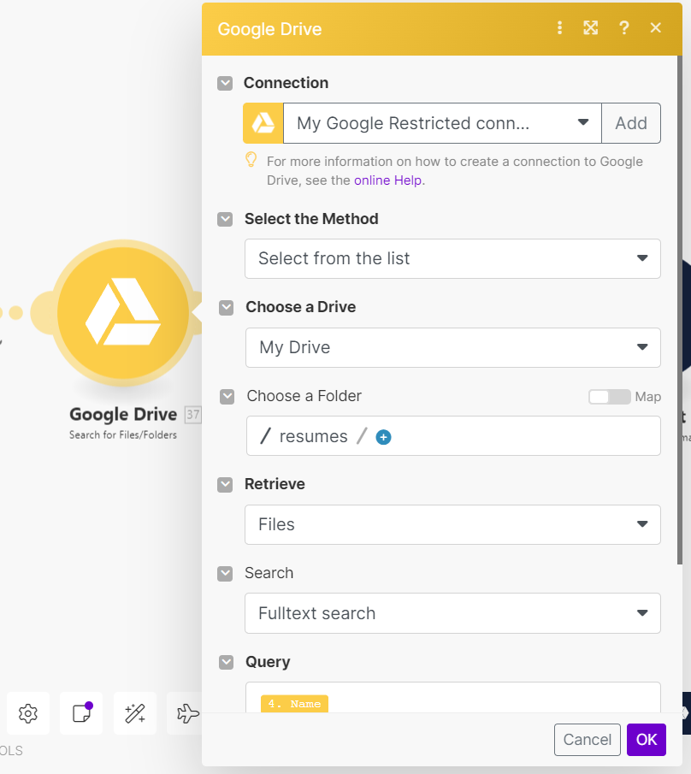

Fig.5 Google Drive module setting for searching the file from the folder

**Step 4:**

**Get Content of a document**

As we advance in our automation journey, we reach the fourth step, which revolves around gathering the essential information from the resumes we've collected. Our objective here is to extract the content from each resume file and consolidate it into a single, unified string.

Imagine each resume as a treasure trove of valuable information, scattered across pages. Our task is to carefully gather all these details and organize them into a cohesive narrative.

To accomplish this task, we employ a specialized function within our automation toolkit. This function acts as a virtual reader, accessing the content of each resume file in a Google Docs format. It's like opening up each document and meticulously examining its contents.

Now, let's dive into the mechanics of this process. Our system utilizes a series of commands to extract the content of each document, capturing it in a format that's easy to work with. This content is then compiled into a single string—a continuous sequence of characters that encapsulates the entire contents of the resume.

In essence, this step serves as a crucial intermediary stage in our automation workflow. By extracting the content of each resume into a unified format, we lay the groundwork for further analysis and processing in subsequent stages.

To put it simply, this step is akin to having a diligent assistant who meticulously reads through each resume, gathers all the important details, and presents them to us in a neat and organized manner. By consolidating the resume content into a single string, we streamline the process of extracting meaningful insights from the resumes of potential candidates.

Fig.6 Google Docs module

Fig.7 Google Docs Setting

**Step 5 :**

**Gathering Information from resume**

As we progress through our automation process, we now arrive at the fifth step, where our focus shifts to extracting specific information from the resumes we've collected. Our objective here is to identify and capture key details from each resume and then store them in a structured format in a Google spreadsheet.

Imagine each resume as a treasure trove of valuable information, containing details about the candidate's qualifications, skills, and experiences. Our task in this step is to sift through this wealth of information and extract the nuggets that are most relevant to our needs.

To accomplish this task, we employ a specialized function within our automation toolkit. This function acts as a virtual investigator, carefully examining each resume and identifying the information we're interested in. It's like having a magnifying glass that helps us zoom in on the most important details.

Once we've identified the relevant information, we save it to a Google spreadsheet in the respective columns. For example, we might extract the candidate's name and save it in the "Name" column, extract their email address and save it in the "Email" column, and so on. This structured approach ensures that the information is organized and easily accessible for future reference.

In essence, this step serves as a crucial stage in our automation process, as it enables us to extract valuable insights from the resumes of potential candidates and store them in a centralized location for easy access and analysis. By streamlining the extraction and storage of information, we enhance the efficiency of our recruitment process and ensure that we have all the necessary details at our fingertips when making hiring decisions.



Fig.8 0Codekit module

Fig.9 0codekit Setting

**Step 6 :**

**Storing Information in Google Spreadsheet**

As we move forward in our automation journey, we've come to the sixth step, where our task is to neatly organize the information we've gathered from the resumes into a Google spreadsheet.

Think of this spreadsheet as a digital notebook, divided into sections for different types of information. Our job here is to carefully transfer the details we've extracted from the resumes into this notebook, making sure each piece of information goes into the right section.

Let's break it down further. If we've found the candidate's name, email, and phone number from their resume, we ensure that each of these details is written down in the correct places in the spreadsheet. It's like filling in the blanks in a form, making sure everything is in its proper place.

This step ensures that all the important information we've collected is neatly organized and easy to find when we need it. It's like tidying up our desk so that we can work more efficiently.

In simple terms, this step is all about making sure that the data we've gathered is neatly arranged and ready for us to use. By keeping everything organized in the spreadsheet, we MAKE it easier to review and analyze the candidate's information during the hiring process.

Fig.10 Google Sheets module

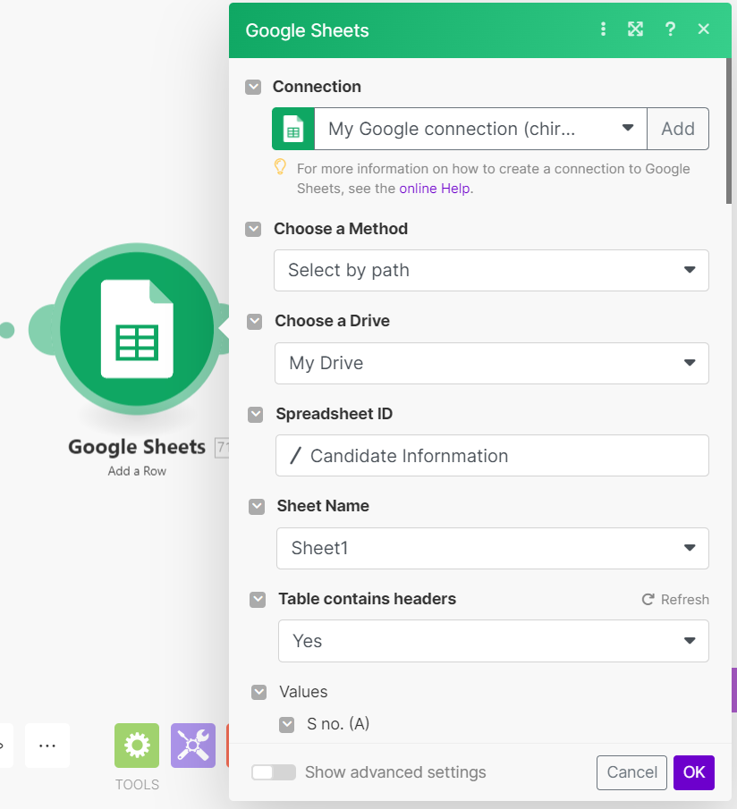

Fig.11 Google Sheets Setting

**Step 7:**

**Sending email to the candidate**

As we approach the culmination of our automation process, we arrive at the pivotal seventh step: reaching out to the candidates through email. This final communication serves as a vital touchpoint, ensuring candidates are informed about the receipt of their email and what steps lie ahead in the recruitment process.

Think of this step as extending a warm welcome to the candidates, assuring them that their communication has been acknowledged and that they're now part of the recruitment journey with us.

In simple terms, we craft an email message that conveys something like, "Hello! We've received your email regarding the job opening, and we're thrilled to see your interest. Rest assured, we're diligently processing your application and will be in touch shortly with further details on what to expect next."

This email serves multiple purposes. It not only provides reassurance to candidates that their application has been received but also sets expectations for the next steps, thereby reducing any uncertainty they may have.

By taking this proactive approach, we not only demonstrate professionalism but also foster a positive candidate experience, which is essential for attracting and retaining top talent. So, while this step may seem straightforward, its impact on candidate engagement and satisfaction cannot be overstated.

In essence, this final communication serves as the bridge between the automated process and the human touch, ensuring candidates feel valued and respected throughout their interaction with ZZ Enterprises.

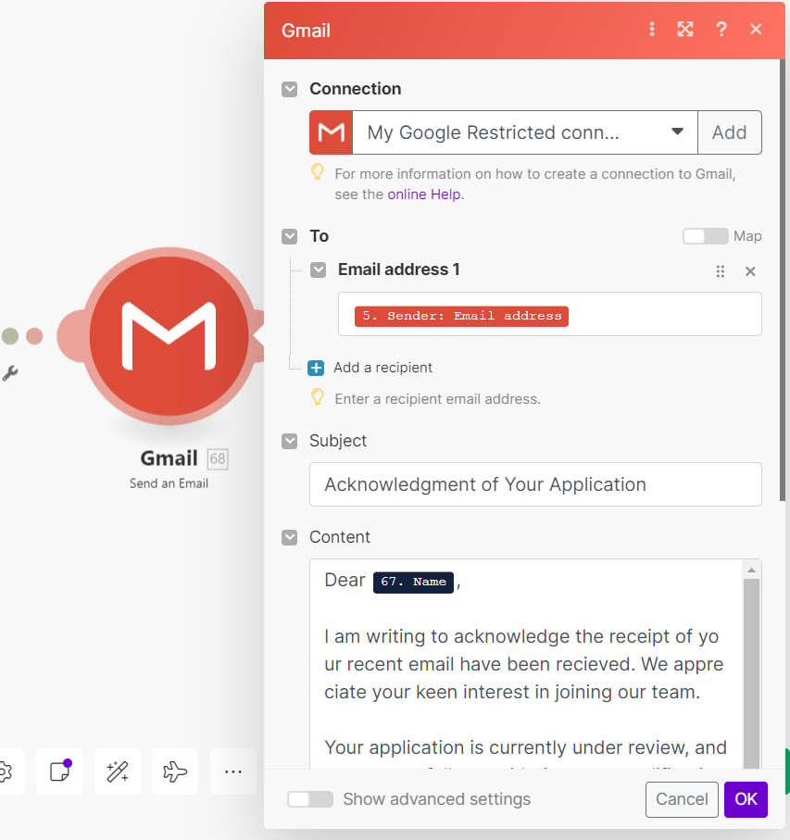

Fig.12 Google Mail Setting for sending response mail

Fig.13 Final Scenario

**Conclusion:**

In conclusion, we've successfully automated HR processes at ZZ Enterprises. Resumes and inquiries received in the HR inbox are now automatically sorted and saved, making it more organised. Any attached resumes are detected and stored by date. We've also created a database with candidate information, including their name, email, contact number, LinkedIn URL, and the date of their email. To top it off, a polite email is sent to candidates to confirm their email receipt and assure them of ZZ's follow-up. All of this MAKEs our HR work more efficient and candidate friendly.

In a nutshell, our automation solution for ZZ Enterprises has transformed how we handle incoming resumes and inquiries. It has brought about the following benefits:

1. **Efficiency:** We've streamlined the process, saving time and effort by automatically sorting and storing relevant resumes and inquiries.
2. **Organization:** All resumes are neatly archived, and a structured database is maintained for candidate information, making it easy to access and manage.
3. **Professionalism:** Candidates receive prompt and personalized acknowledgment emails, creating a positive first impression and ensuring they know we've received their information.
4. **Data Accuracy:** By extracting information directly from emails and resumes, we reduce the risk of manual errors in data entry.
5. **Timeliness:** With automatic date-based storage and email notifications, we ensure that everything is up-to-date and that candidates are informed promptly.

Overall, our solution has elevated the efficiency, organisation, and professionalism of ZZ Enterprises' HR functions, making it a win-win for both the company and the candidates we interact with.

**Future Scope:**

The future scope for the HR automation PoC at ZZ Enterprises is promising, with several opportunities for further enhancements and expansions:

**1. Machine Learning and AI Integration:** Incorporating machine learning and artificial intelligence can enhance the system's ability to categorise and extract relevant information from emails and resumes more accurately. This can lead to more advanced candidate profiling and better matching with job opportunities.

**2. Natural Language Processing (NLP):** Utilising NLP algorithms can help in understanding the content of emails and resumes, enabling the system to recognise skills, experiences, and qualifications more effectively. This can assist in better candidate matching and filtering.

**3. Advanced Reporting and Analytics:** Developing advanced reporting and analytics tools can provide HR with valuable insights into recruitment trends, candidate sources, and the efficiency of the hiring process. This data can inform strategic decision-making.

**4. Integration with Recruitment Software:** Integrating the HR automation system with existing recruitment and applicant tracking systems can create a seamless workflow. This can facilitate easier candidate management and collaboration among team members.

**5. Multi-Channel Integration:** Expanding the system to handle inquiries from various communication channels such as social media, chatbots, and third-party job portals can provide a more comprehensive approach to candidate engagement.

**6. Mobile Accessibility:** Making the system accessible via mobile devices can enable HR professionals to manage recruitment tasks on the go, improving responsiveness and efficiency.

**7. Security and Compliance:** Enhancing data security and compliance measures to protect sensitive candidate information is critical as data privacy regulations evolve.

**8. Feedback Mechanisms:** Incorporating candidate feedback mechanisms can help improve the recruitment process further and enhance the company's reputation as an employer.

**9. Continuous Training and Support:** Providing ongoing training and support to HR staff and system users is crucial to ensure the effective utilisation of the automated processes.

**10. Global Expansion:** If ZZ Enterprises has global operations, extending the system to accommodate international languages and regulations will be essential for managing a diverse talent pool.

**11. Cost Optimisation:** Continuously assess and optimise the cost of the automation system, including software licensing, infrastructure, and maintenance, to ensure it remains cost-effective.

**BIBLIOGRAPHY:**

1. MAKE: <https://www.make.com/>
2. Gmail : <https://developers.google.com/gmail>
3. Google Drive : <https://developers.google.com/drive>
4. Google Sheets : [https://developers.google.com/sheets](https://developers.google.com/sheets/)
5. 0 code kit : <https://0codekit.com/>